CRITICAL APPRAISAL SUMMARIES:
- ROB2 Bar graph:
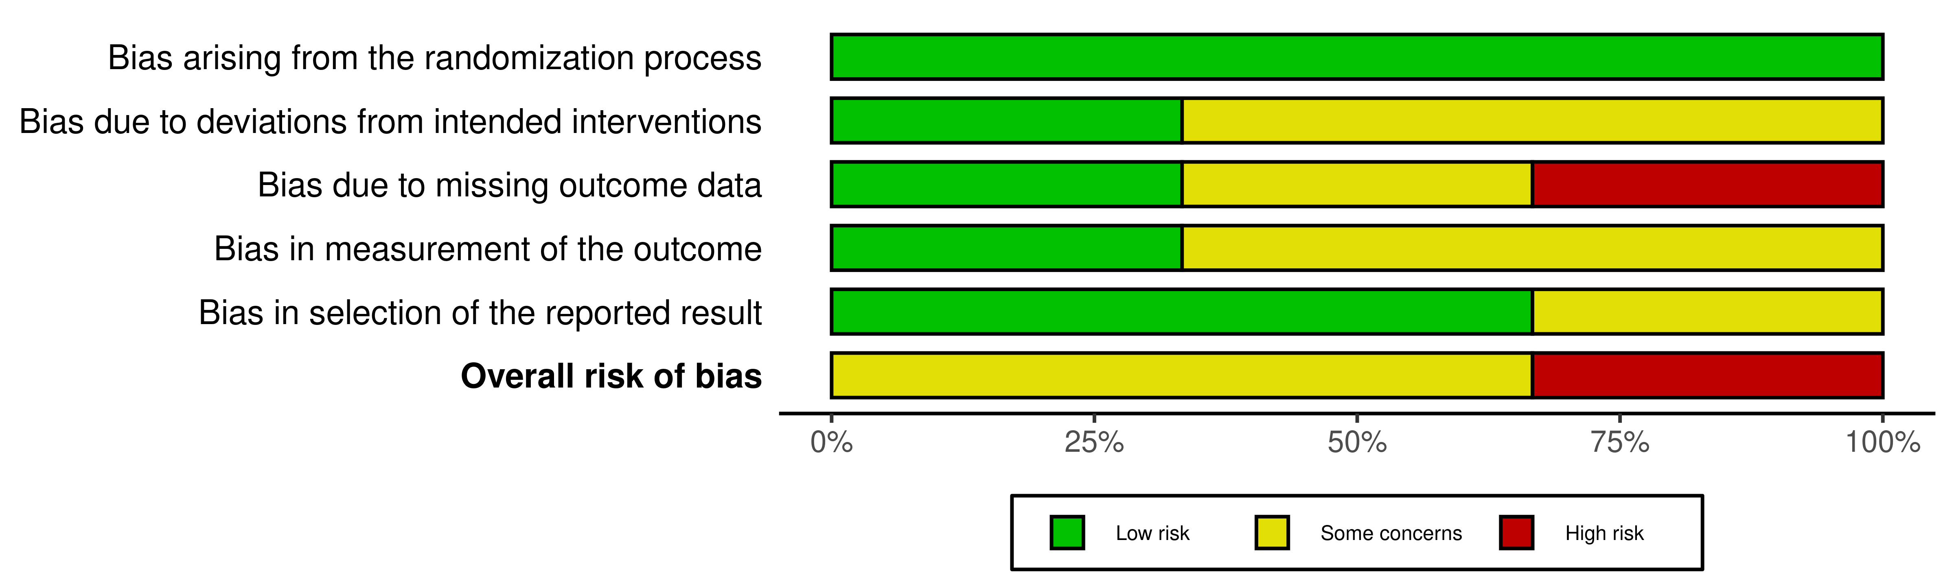- ROB 2 Traffic Lights:
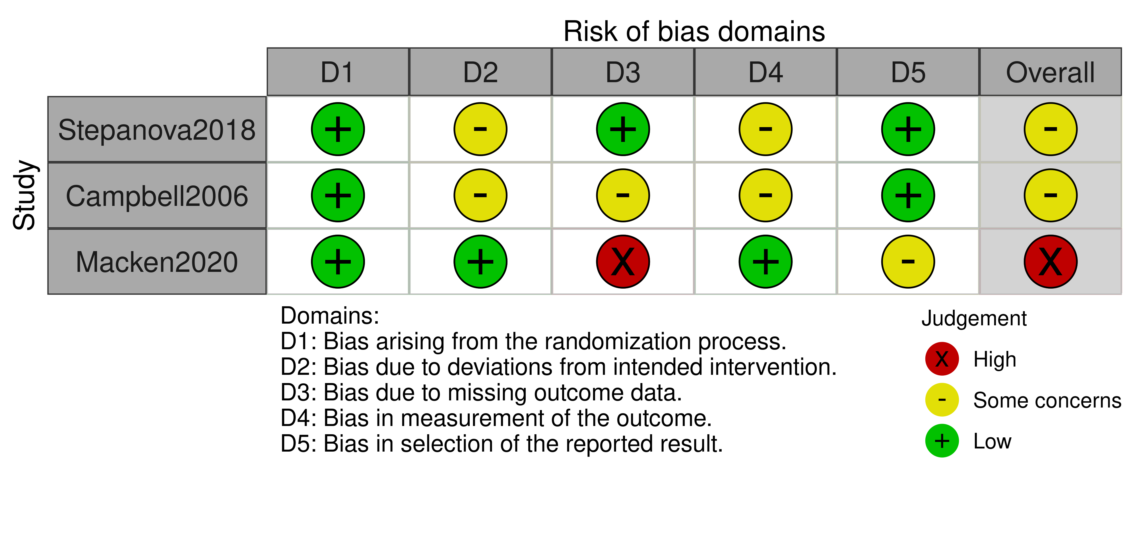
- ROBINS-I:
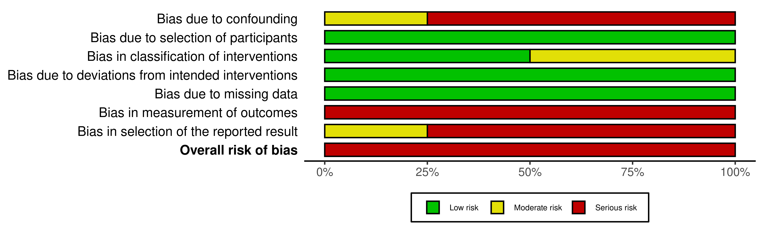
- ANALYTICAL STUDIES:
STUDY ID | Were the criteria for inclusion in the sample clearly defined? | Were the study subjects and the setting described in detail? | Was the exposure measured in a valid and reliable way? | Were objective, standard criteria used for measurement of the condition? | Were confounding factors identified? | Were strategies to deal with confounding factors stated? | Were the outcomes measured in a valid and reliable way? | Was appropriate statistical analysis used?
Kieffer2022 | Yes | Yes | Yes | Yes | Yes | Yes | Yes | Yes
- COHORT STUDIES:
STUDY ID | Were the two groups similar and recruited from the same population? | Were the exposures measured similarly to assign people to both exposed and unexposed groups? | Was the exposure measured in a valid and reliable way? | Were confounding factors identified? | Were strategies to deal with confounding factors stated? | Were the groups/participants free of the outcome at the start of the study (or at the moment of exposure)? | Were the outcomes measured in a valid and reliable way? | Was the follow up time reported and sufficient to be long enough for outcomes to occur? | Was follow up complete, and if not, were the reasons to loss to follow up described and explored? | Were strategies to address incomplete follow up utilized? | Was appropriate statistical analysis used?
Kaur2024 | Yes | Yes | Yes | Yes | No | No | Yes | Yes | Yes | Yes | Yes
Johnson2022 | Yes | Yes | Yes | Yes | Yes | Yes | Yes | Yes | No | No | Yes
Murray2022 | NA | NA | Yes | No | No | Yes | Yes | Yes | Yes | No | Yes
Orman2013 | Yes | Yes | Yes | Yes | Yes | Yes | Yes | Yes | Yes | No | Yes
Monsky2009 | Unclear | Yes | Yes | Yes | No | Yes | Yes | Yes | No | No | Yes

